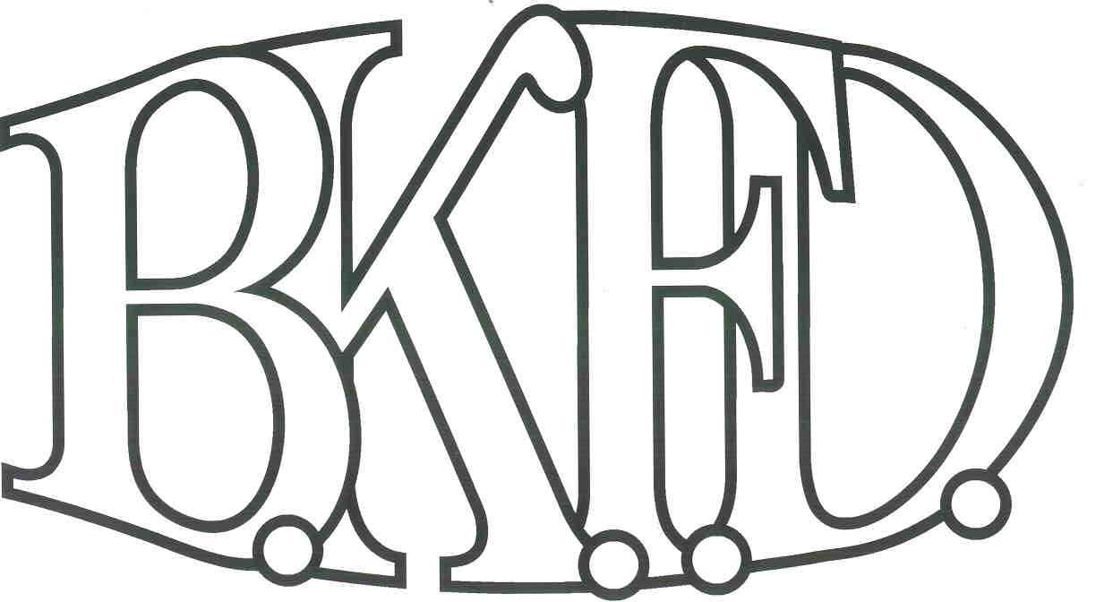
Bristol Kendall Fire Department

103 East Beaver Street

Yorkville, IL 60560

Phone: 630-553-6186

Fax: 630-553-1482

Foreign Fire Insurance Board 01/24/2022 Minutes

The monthly business meeting for the Bristol-Kendall Fire Department Foreign Fire Insurance Board was called to order at 1603 hrs. On 01/24/2022. Roll call was taken showing Jeffers, King, Enlow present, Bateman and Dunn excused.

The minutes were read and a motion was made by Enlow to approve the minutes and a second was made by King. The minutes for 10/7/2021 were approved.

The treasurer’s report was unavailable for this meeting

The following bills were presented for payment:

Station knifes for station 1, 2, 3

Roll Call Vote:

Chief Bateman - excused

Joe Jeffers - yes

Nate King - yes

Audrey Enlow - yes

Alex Dunn- excused

Old Business:

Reading of changes to class reimbursement bylaw from $1200 to $1500 from ffib (second reading)

New Business:

The board acknowledged the Higher Education Intent forms that were submitted by eligible members.

None.

King proposed buying additional duffle/backpacks 5.11 for members and upcoming members to not exceed $2000.

Gear bags were discussed and we currently do not need any at this time.

Lynd’s Kitchen Proposal for kitchen supplies was approved to not exceed $1200.

Roll Call Vote:

-Chief Bateman - excused

-Joe Jeffers - yes

-Nate King - yes

-Audrey Enlow - yes

-Alex Dunn- excused

All Intent forms were approved.

Hire Education reimbursement Josh McElroy for fire structure and protection systems

Roll Call Vote:

Chief Bateman - excused

Joe Jeffers - yes

Nate King - yes

Audrey Enlow - yes

Alex Dunn- excused

A motion to adjourn the meeting was made by Enlow with a second made by King

Meeting adjourned at 1633.

