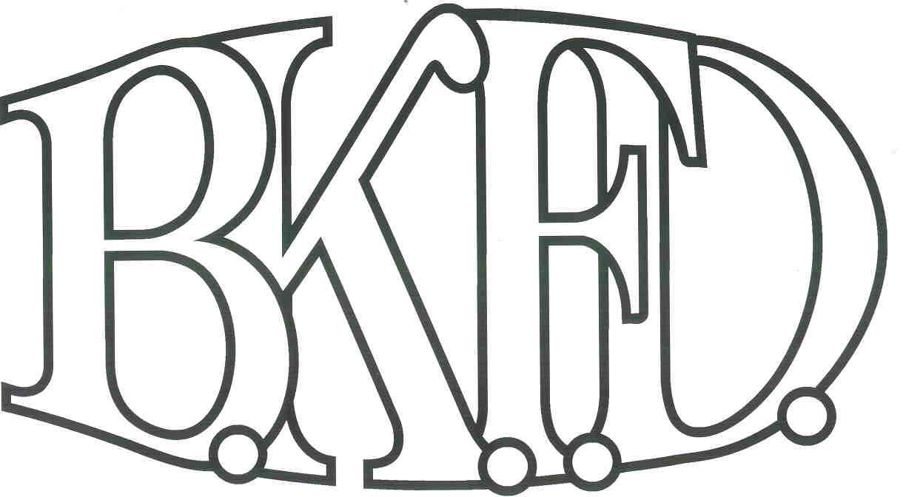
Bristol Kendall Fire Department

103 East Beaver Street

Yorkville, IL 60560

Phone: 630-553-6186

Fax: 630-553-1482

Foreign Fire Insurance Board 02/03/2022 Minutes

The monthly business meeting for the Bristol-Kendall Fire Department Foreign Fire Insurance Board was called to order at 1600 hrs. on 02/03/2022. Roll call was taken showing A/O Jeffers, Chief Bateman, A/O Enlow, and Dunn present, A/O King absent.

The minutes were read and a motion was made by A/O Jeffers to approve the minutes and a second was made by A/O Enlow. The minutes for 01/24/2022 were approved.

The treasurer’s report was read and a motion was made by A/O Jeffers to approve the treasurer’s report and a second was made by A/O Enlow. The treasurer’s report for 02/03/2022was approved.

Old Business:

Reading of changes to the class reimbursement bylaw from $1200 to $1500 from FFIB (3rd reading)

Roll Call Vote:

Chief Bateman - (Yes)

Joe Jeffers - (Yes)

Nate King - (excused)

Audrey Enlow - (Yes)

Alex Dunn- (Yes)

King-5.11 bags not to exceed $2000- Approved

Roll Call Vote:

Chief Bateman - (Yes)

Joe Jeffers - (Yes)

Nate King - (excused)

Audrey Enlow - (Yes)

Alex Dunn- (Yes)

New Business:

The board acknowledged the Higher Education Intent forms that were submitted by eligible members.

Dan Stanford for Applications of Technical Writing $1184.55

Roll Call Vote:

Chief Bateman - (Yes)

Joe Jeffers - (Yes)

Nate King - (excused)

Audrey Enlow - (Yes)

Alex Dunn- (Yes)

FFIB elections for Pres. Jeffers and VP King’s positions

Put out for Nominees for March meeting

Vote in April to start at May meeting

All Intent forms were approved.

The board discussed a proposal submitted by PM Lynd. The proposal was submitted. Total cost not to exceed $1200 out of the station 2 fund. (After discussion, a motion was made to approve the proposal by Jeffers, and a second was made by Dunn.

Roll Call Vote:

Chief Bateman - (Yes)

Joe Jeffers - (Yes)

Nate King - (excused)

Audrey Enlow - (no)

Alex Dunn- (no)

Proposal tabled for funding. Proposal tabled until next meeting due to stalemate vote.

A motion to adjourn the meeting was made by Jeffers with a second made Enlow

Meeting adjourned at 16:21pm.

