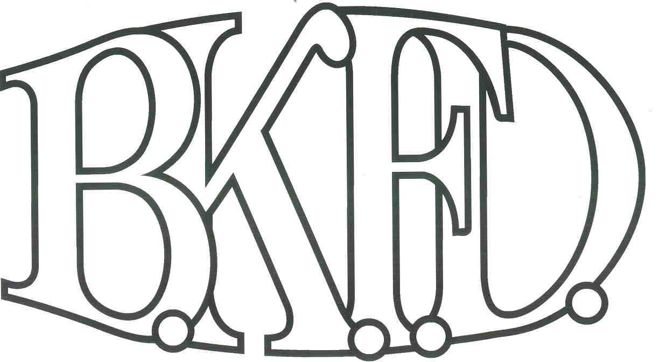
Bristol Kendall Fire Department

103 East Beaver Street

Yorkville, IL 60560

Phone: 630-553-6186

Fax: 630-553-1482

Foreign Fire Insurance Board 3/3/2022 Minutes

The monthly business meeting for the Bristol-Kendall Fire Department Foreign Fire Insurance Board was called to order at 16:08hrs on 3/3/2022. Roll call was taken showing Chief Bateman, A/O Jeffers, A/O King, A/O Enlow, and FF Dunn present.

The minutes were read and a motion was made by A/O Enlow to approve the minutes and a second was made by A/O Jeffers. The minutes for 2/3/2022 were approved.

The treasurer’s report was read and a motion was made by A/O King to approve the treasurer’s report and a second was made by FF Dunn. The treasurer’s report for 3/3/2022 was approved.

No new bills were presented for payment:

Old Business:

Changes to the bylaws regarding the Class reimbursement changes were approved by the board.

5.11 bag order has been placed.

4 members expressing interest for the 2 openings on the FFIB were accepted. A/O Jeffers will work on creating the voting system and have the ballots tallied for the April meeting.

The board discussed the tabled proposal submitted by PM Lynd. The proposal was submitted. Total cost not to exceed $1200 out of the station 2 fund. (After discussion, a motion was made to approve the proposal by Jeffers, and a second was made by Dunn.)

Roll Call Vote:

Chief Bateman - (Yes)

Joe Jeffers - (no)

Nate King - (yes)

Audrey Enlow - (no)

Alex Dunn- (no)

Proposal was denied for funding. It is the thought by the board that the funds would be better used to replace the dining chairs and relocate the existing chairs to the apparatus floor.

New Business:

The board acknowledged the Higher Education Intent forms that were submitted by eligible members.

None.

All Intent forms were approved.

The board discussed a proposal submitted by FF/PM R. Krouse The proposal was submitted. Total cost not to exceed $900 out of the general fund. (After discussion, a motion was made to approve the proposal by Chief Bateman, and a second was made by FF Dunn.

Roll Call Vote:

Chief Bateman - (Yes)

Joe Jeffers - (Yes)

Nate King - (Yes)

Audrey Enlow - (Yes)

Alex Dunn- (Yes)

Proposal (Approved) for funding.

A motion to adjourn the meeting was made by A/O Jeffers with a second made by FF Dunn.

Meeting adjourned at 16:21.

