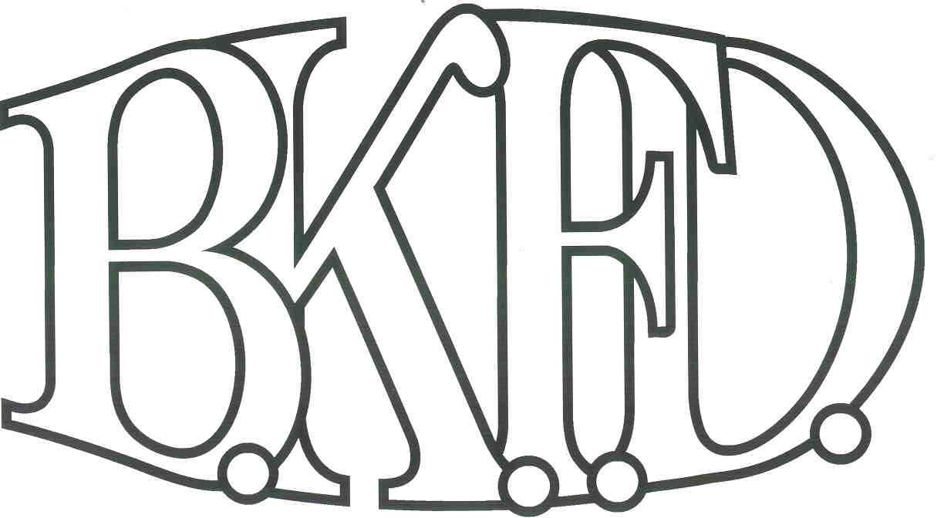
Bristol Kendall Fire Department

103 East Beaver Street

Yorkville, IL 60560

Phone: 630-553-6186

Fax: 630-553-1482

Foreign Fire Insurance Board 4/7/2022 Minutes

The monthly business meeting for the Bristol-Kendall Fire Department Foreign Fire Insurance Board was called to order at 15:57 hrs. on 4/7/2022. Roll call was taken showing Chief Bateman, A/O Jeffers, A/O Enlow and FF Dunn present and A/O King excused.

The minutes were read and a motion was made by A/O Enlow to approve the minutes and a second was made by A/O Jeffers. The minutes for 3/3/2022 were approved.

The treasurer’s report was read and a motion was made by FF Dunn to approve the treasurer’s report and a second was made by A/O Enlow. The treasurer’s report for 4/7/2022 was approved.

The following bills were presented for payment: None.

Old Business:

5.11 bag update. Tabled.

Board election completed. FF Krouse and A/O Johnson voted on the board.

New Business:

The board discussed a proposal submitted by FF Christine Valaski. The proposal was submitted at a total cost not to exceed $1200 out of the station 3 allotment for new kitchen ware. After discussion, a motion was made to approve the proposal by FF Dunn and a second was made by A/O Enlow.

Roll Call Vote:

Chief Bateman - (Yes)

Joe Jeffers - (Yes)

Nate King - (Excused)

Audrey Enlow - (Yes)

Alex Dunn- (Yes)

Proposal (Approved) for funding.

The board discussed a proposal submitted by FF Dunn. The proposal was submitted at a total cost not to exceed $400 out of the general fund for saw blade and chain storage solutions. (After discussion, a motion was made to approve the proposal by A/O Enlow and a second was made by A/O Jeffers.

Roll Call Vote:

Chief Bateman - (Yes)

Joe Jeffers - (Yes)

Nate King - (excused)

Audrey Enlow - (Yes)

Alex Dunn- (Yes)

A motion to adjourn the meeting was made by A/O Enlow with a second made by FF Dunn

Meeting adjourned at 16:09.

