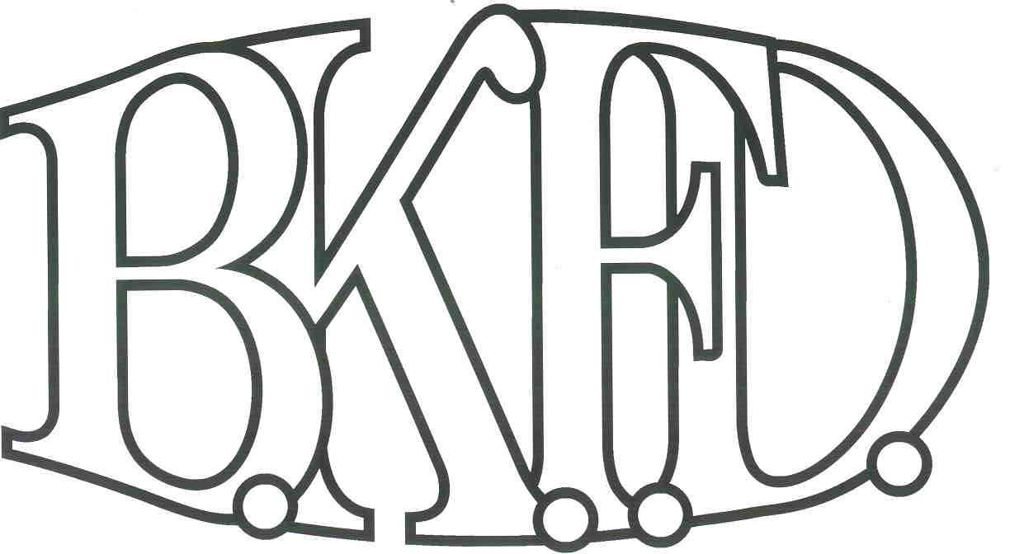
Bristol Kendall Fire Department

103 East Beaver Street

Yorkville, IL 60560

Phone: 630-553-6186

Fax: 630-553-1482

Foreign Fire Insurance Board 5/5/2022 Minutes

The monthly business meeting for the Bristol-Kendall Fire Department Foreign Fire Insurance Board was called to order at 16:34 hrs. on 5/5/2022. Roll call was taken showing A/O Enlow, A/O Johnson, FF/PM Krouse, FF/EMT Dunn present and Chief Bateman absent.

The minutes were read and a motion was made by A/O Enlow to approve the minutes and a second was made by A/O Johnson. The minutes for 4/7/2022 were approved.

The treasurer’s report was no read due to absence of treasurer.

The following bills were presented for payment:

Roll Call Vote:

Chief Bateman - (Yes/no/excused)

Brandon Johnson - (Yes/no/excused)

Ryan Krouse - (Yes/no/excused)

Audrey Enlow - (Yes/no/excused)

Alex Dunn- (Yes/no/excused)

Old Business:

5.11 bag delivered and are being distributed.

New Business:

The board acknowledged the Higher Education Intent forms that were submitted by eligible members.

Shamsuddin request approved up to $350.00 payable upon completion with provided receipt and course completion certificate.

Roll Call Vote:

Chief Bateman - (excused)

Brandon Johnson - (Yes)

Ryan Krouse - (Yes)

Audrey Enlow - (Yes)

Alex Dunn- (Yes)

All Intent forms were approved.

The board discussed a proposal submitted by A/O Johnson The proposal was submitted to pay a company to complete yearly hose testing and re pack the hose beds. Total cost not to exceed $36000 for 3 years out of the FFIB general fund. After discussion, a motion was made to TABLE the proposal by A/O Enlow to facilitate discussions with Chief Bateman.

Roll Call Vote:

Roll Call Vote:

Chief Bateman - (excused)

Brandon Johnson - (Yes)

Ryan Krouse - (Yes)

Audrey Enlow - (Yes)

Alex Dunn- (Yes)

Proposal Tabled for funding.

- Bylaw review meeting scheduled for 5/25/2022 15:00 station 1
- Next meeting 6/2/2022 station 1

A motion to adjourn the meeting was made by A/O Enlow with a second made by Ryan Krouse

Meeting adjourned at 16:48.

