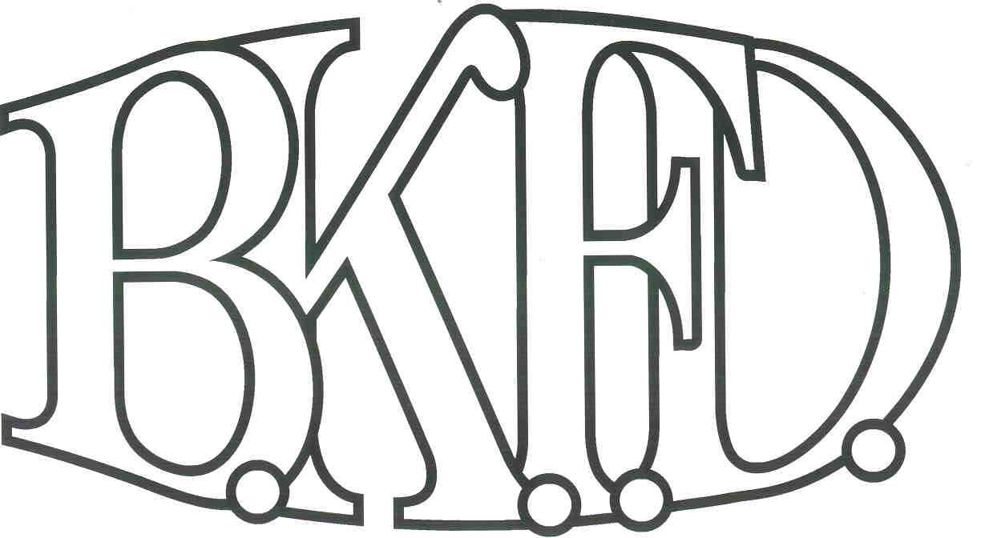
Bristol Kendall Fire Department

103 East Beaver Street

Yorkville, IL 60560

Phone: 630-553-6186

Fax: 630-553-1482

Foreign Fire Insurance Board 6/2/2022 Minutes

The monthly business meeting for the Bristol-Kendall Fire Department Foreign Fire Insurance Board was called to order at 15:59 hrs. on 6/6/2022. Roll call was taken showing Chief Bateman, A/O Enlow, A/O Johnson, FF/PM Krouse present, and FF/EMT Dunn excused.

The minutes were read and a motion was made by FF/PM Krouse to approve the minutes and a second was made by A/O Johnson. The minutes for 5/5/2022 were approved.

The treasurer’s report was read and a motion was made by Chief Bateman to approve the treasurer’s report and a second was made by A/O Enlow. The Month’s beginning balance was $133,881.03 and the ending balance is $131,352.46. The treasurer’s report for 6/2/2022 was approved.

The following bills were presented for payment:

None

Old Business:

The board discussed a proposal submitted by A/O Johnson. The proposal was submitted to pay a company to complete yearly hose testing and re-pack the hose beds. Total cost not to exceed $36,000 out of the general fund. (After discussion, a motion was made to approve the proposal by (member making motion), and a second was made by (member making the second).

New Business:

The board acknowledged the Higher Education Intent forms that were submitted by eligible members.

A/O Shamsuddin request for reimbursement of $375 for FD incident safety officer. A/O

Shamsuddin provided certificate of completion.

Roll Call Vote:

Chief Bateman - (Yes)

Audrey Enlow - (Yes)

Brandon Johnson - (Yes)

Ryan Krouse - (Yes)

Alex Dunn- (excused)

Proposal approved for funding.

All Intent forms were approved.

The board discussed a proposal submitted by FF/EMT Dunn. The proposal was submitted to purchase fans for each bunk room. Total cost not to exceed $450 out of the General fund. (After discussion, a motion was made to approve the proposal by A/O Enlow, and a second was made by A/O Johnson.

Roll Call Vote:

Chief Bateman - (Yes)

Audrey Enlow - (Yes)

Brandon Johnson - (Yes)

Ryan Krouse - (Yes)

Alex Dunn- (excused)

Proposal approved for funding.

Next meeting 7/7/2022 Station 1

A motion to adjourn the meeting was made by A/O Enlow with a second made by FF/PM Krouse

Meeting adjourned at 1617.

