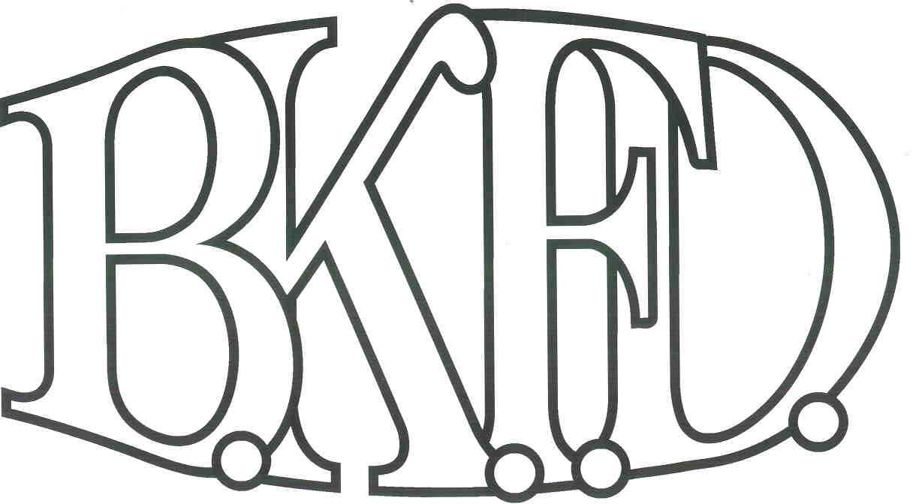
Bristol Kendall Fire Department

103 East Beaver Street

Yorkville, IL 60560

Phone: 630-553-6186

Fax: 630-553-1482

Foreign Fire Insurance Board 07/07/2022 Minutes

The monthly business meeting for the Bristol-Kendall Fire Department Foreign Fire Insurance Board was called to order at 1608 hrs. on 07/07/2022. Roll call was taken showing AO Enlow, AO Johnson, Chief Bateman, FF/PM Krouse present and FF/EMT Dunn excused.

The minutes were read and a motion was made by A/O Johnson to approve the minutes and a second was made by FF/PM Krouse. The minutes for 06/02/2022 were approved.

The treasurer’s report was read and a motion was made by A/O Enlow to approve the treasurer’s report and a second was made by FF/PM Krouse. The Month’s beginning balance was $131,352.46 and the ending balance is $131,364.55. The treasurer’s report for 07/07/2022 was approved.

The following bills were presented for payment: None

Old Business:

None

New Business:

The board acknowledged the Higher Education Intent forms that were submitted by eligible members.

FF/EMT Wolf request for reimbursement of $1500 for Public safety management classes. FF/EMT Wolf provided proof of course completion.

Roll Call Vote:

Chief Bateman - (Yes)

Audrey Enlow - (Yes)

Brandon Johnson - (Yes)

Ryan Krouse - (Yes)

Alex Dunn- (Excused)

Proposal (Approved) for funding.

All Intent forms were approved.

The board discussed a proposal submitted by A/O Enlow. The proposal was submitted to replenish the bath/shower towels at station one. Total cost not to exceed $200 out of the Station one allotment fund. (After discussion, a motion was made to approve the proposal by A/O Johnson, and a second was made by FF/PM Krouse.

Roll Call Vote:

Chief Bateman - (Yes)

Audrey Enlow - (Yes)

Brandon Johnson - (Yes)

Ryan Krouse - (Yes)

Alex Dunn- (Excused)

Proposal (Approved) for funding.

The board discussed a proposal submitted by FF/EMT Dunn. The proposal was submitted to make a donation to the Illinois Fallen Firefighter Memorial Foundation and obtain a personalized brick in the memorial courtyard. Total cost not to exceed $250 out of the General fund. (After discussion, a motion was made to approve the proposal by FF/PM Krouse, and a second was made by A/O Johnson.

Roll Call Vote:

Chief Bateman - (Yes)

Audrey Enlow - (Yes)

Brandon Johnson - (Yes)

Ryan Krouse - (Yes)

Alex Dunn- (Excused)

Proposal (Approved) for funding.

.

The board discussed a proposal submitted by FF/EMT Dunn. The proposal was submitted to replace the aging grills at all of the stations. Total cost not to exceed $3650 out of the General fund. (After discussion, a motion was made to approve the proposal by A/O Johnson, and a second was made by FF/PM Krouse.

Roll Call Vote:

Chief Bateman - (Yes)

Audrey Enlow - (Yes)

Brandon Johnson - (Yes)

Ryan Krouse - (Yes)

Alex Dunn- (Excused)

Proposal (Approved) for funding.

Next meeting 08/04/2022 Station 1

A motion to adjourn the meeting was made by A/O Enlow with a second made by FF/PM Krouse

Meeting adjourned at 1620.

