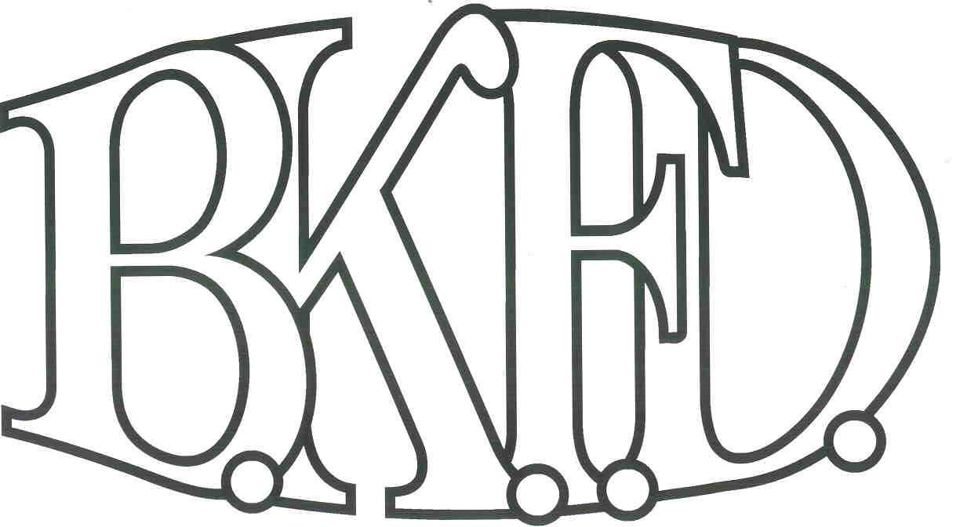
Bristol Kendall Fire Department

103 East Beaver Street

Yorkville, IL 60560

Phone: 630-553-6186

Fax: 630-553-1482

Foreign Fire Insurance Board 01/05/2023 Minutes

The monthly business meeting for the Bristol-Kendall Fire Department Foreign Fire Insurance Board was called to order at 1600 hrs. on 01/05/2023. Roll call was taken showing AO Enlow, LT Johnson, Chief Bateman, FF/EMT Dunn, FF/PM Krouse present.

The minutes were read and a motion was made by FF/EMT Dunn to approve the minutes and a second was made by FF/PM Krouse. The minutes for 11/03/2022 were approved.

The treasurer’s report was read and a motion was made by FF/EMT Dunn to approve the treasurer’s report and a second was made by LT Johnson. The Month’s beginning balance was $181,983.20 and the ending balance is $171,252.17. The treasurer’s report for 01/05/2023 was approved.

The following bills were presented for payment:

None

Old Business:

The board discussed an outstanding bill for the approved sleep number beds, an update was given that FF/EMT Szopinski was having a difficult time communicating with the company about purchasing the beds and that he was currently working on getting it resolved.

New Business:

The board acknowledged the Higher Education Intent forms that were submitted by eligible members.

None.

All Intent forms were approved.

The 2023 Foreign Fire Insurance Board meeting dates were presented and a motion was made by LT Johnson to approve the meeting dates and a second was made by FF/EMT Dunn. The 2023 Foreign Fire Insurance Board meeting dates were approved.

Next meeting 02/02/2023 Main Station

A motion to adjourn the meeting was made by LT Johnson with a second made by FF/EMT Dunn Meeting adjourned at 1602.

