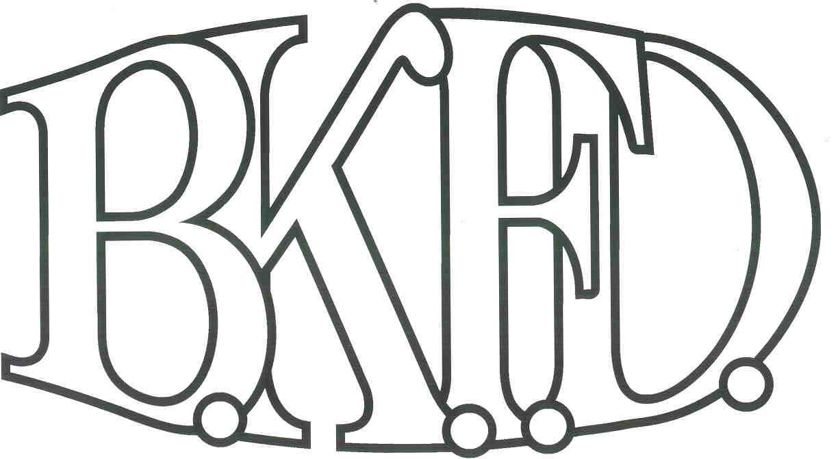
Bristol Kendall Fire Department

103 East Beaver Street

Yorkville, IL 60560

Phone: 630-553-6186

Fax: 630-553-1482

Foreign Fire Insurance Board 02/02/2023 Minutes

The monthly business meeting for the Bristol-Kendall Fire Department Foreign Fire Insurance Board was called to order at 1601 hrs. on 02/02/2022. Roll call was taken showing AO Enlow, FF/EMT Dunn, Lt. Johnson, Chief Bateman present and FF/PM Krouse excused.

The minutes were read and a motion was made by FF/EMT Dunn to approve the minutes and a second was made by LT. Johnson. The minutes for 01/05/2023 were approved.

The treasurer’s report was read and a motion was made by FF/EMT Dunn to approve the treasurer’s report and a second was made by LT. Johnson. The Month’s beginning balance was $171,252.17 and the ending balance is $167,880.69 The treasurer’s report for 02/02/2023 was approved.

The following bills were presented for payment:

Superior Knife

Roll Call Vote:

Chief Bateman - Yes

Audrey Enlow – Yes

Brandon Johnson - Yes

Ryan Krouse - Excused

Alex Dunn- Yes

Old Business:

Update on the approved Sleep number beds

The previous quote had expired due to FF/EMT Szopinski inability to contact Sleep numbers commercial sales department, a new quote will be obtained.

New Business:

The board acknowledged the Higher Education Intent forms that were submitted by eligible members.

None.

All Intent forms were approved.

The board discussed a proposal submitted by LT. Johnson. The proposal was submitted to purchase 60 Survivor X right angle flashlights. Total cost not to exceed $7900 out of the general fund. (After discussion, a motion was made to table the proposal by Chief Bateman, and a second was made by FF/EMT Dunn.

Roll Call Vote:

Chief Bateman - Yes

Audrey Enlow – Yes

Brandon Johnson - yes

Ryan Krouse - Excused

Alex Dunn- Yes

Proposal Tabled for funding.

The board discussed a proposal submitted by FF/EMT Dunn. The proposal was submitted to purchase a watch desk for the station one bay. Total cost not to exceed $1750 out of the Station one allotment fund. (After discussion, a motion was made to approve the proposal by AO Enlow, and a second was made by FF/EMT Dunn.

Roll Call Vote:

Chief Bateman - Yes

Audrey Enlow – Yes

Brandon Johnson - Yes

Ryan Krouse - Excused

Alex Dunn- Yes

Proposal Approved for funding.

Next meeting March 2nd , 2023 1600 hrs Station 1

A motion to adjourn the meeting was made by LT. Johnson with a second made by FF/EMT Dunn

Meeting adjourned at 1613 hrs.

