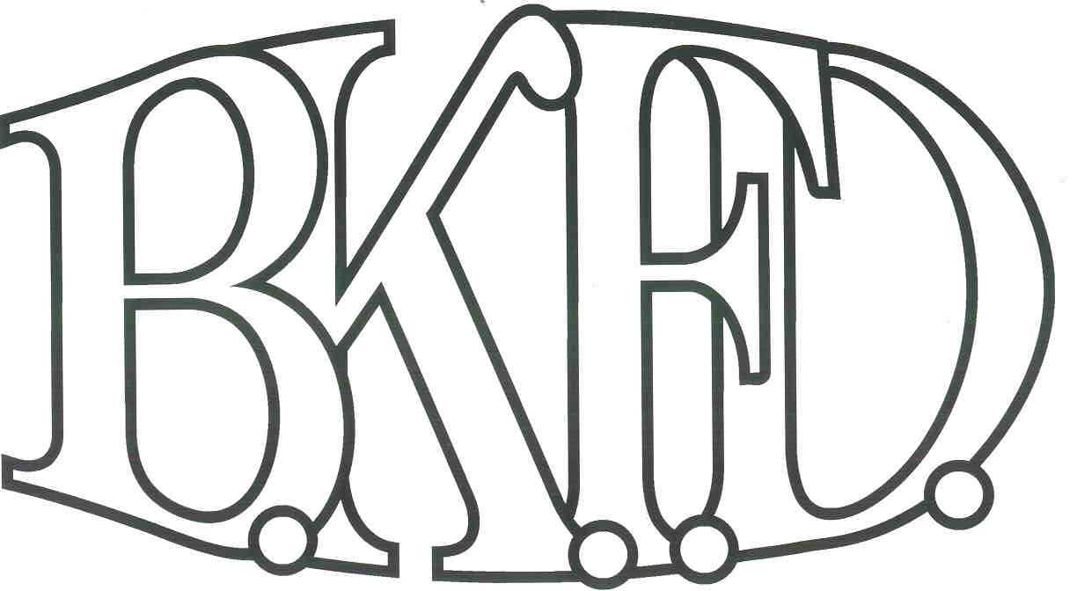
Bristol Kendall Fire Department

103 East Beaver Street

Yorkville, IL 60560

Phone: 630-553-6186

Fax: 630-553-1482

Foreign Fire Insurance Board 04/06/23 Minutes

The monthly business meeting for the Bristol-Kendall Fire Department Foreign Fire Insurance Board was called to order at 1600 hrs. on 04/06/23. Roll call was taken showing Chief Bateman, Lt. Johnson, FF/EMT Dunn, FF/PM Krouse present and AO Enlow excused.

The minutes were read and a motion was made by Lt. Johnson to approve the minutes and a second was made by FF/EMT Dunn. The minutes for 03/02/23 were approved.

The treasurer’s report was read and a motion was made by Lt. Johnson to approve the treasurer’s report and a second was made by FF/ EMT Dunn. The Month’s beginning balance was $167,258.13and the ending balance is $167528.04. The treasurer’s report for 04/06/23 was approved.

The following bills were presented for payment:

Stevens Silk Screen

Menards

Roll Call Vote:

Chief Bateman - Yes

Audrey Enlow - Excused

Brandon Johnson - Yes

Ryan Krouse - Yes

Alex Dunn- Yes

Old Business:

None

New Business:

The board acknowledged the Higher Education Intent forms that were submitted by eligible members.

None.

All Intent forms were approved.

The board discussed the two upcoming vacancies on the Foreign Fire Board with FF/EMT Szopinski, FF/PM Wagner, FF/PM Jordan, FF/PM Beck and FF/PM Horner interested in running for the position. The Board approved the candidates and instructed the secretary to start election process.

Next meeting 04/06/23 Station one

A motion to adjourn the meeting was made by FF/EMT Dunn with a second made by FF/PM Krouse

Meeting adjourned at 1607.

