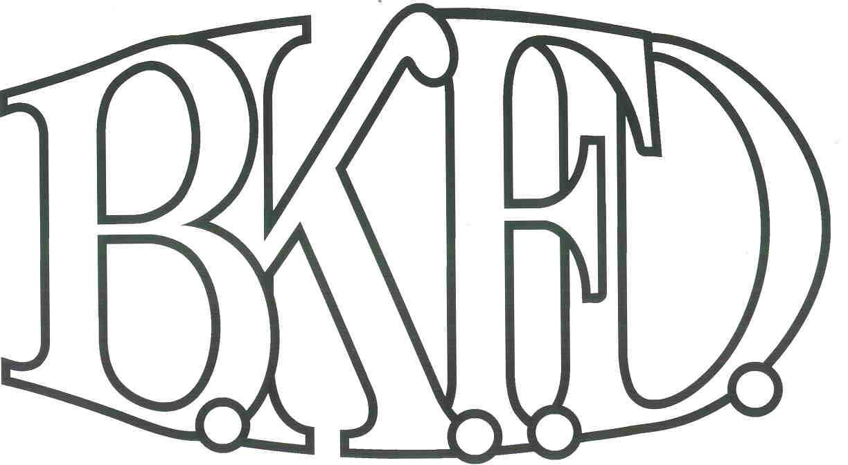
Bristol Kendall Fire Department

103 East Beaver Street

Yorkville, IL 60560

Phone: 630-553-6186

Fax: 630-553-1482

Foreign Fire Insurance Board 05/04/2023Minutes

The monthly business meeting for the Bristol-Kendall Fire Department Foreign Fire Insurance Board was called to order at 1600 hrs. on 05/04/2023. Roll call was taken showing LT Johnson, Chief Bateman, FF/EMT Dunn FF/PM Krouse present and AO Enlow excused.

The minutes were read and a motion was made by LT Johnson to approve the minutes and a second was made by FF/EMT Dunn. The minutes for 04/06/2023 were approved.

The treasurer’s report was read and a motion was made by FF/EMT Dunn to approve the treasurer’s report and a second was made by FF/PM Krouse. The Month’s beginning balance was $167,528.04 and the ending balance is $167,174.88. The treasurer’s report for 05/04/2023 was approved.

The following bills were presented for payment: None

Old Business:

None

New Business:

The board acknowledged the Higher Education Intent forms that were submitted by eligible members.

None.

All Intent forms were approved.

The board counted votes of the FFIB election the results showed, FF/PM Beck obtaining 10 out of 36 votes and FF/PM Horner obtaining 9 out of 36 votes.

The board discussed a proposal submitted by FF/PM Jordan. The proposal was submitted to Purchase 23 C4 sleep number mattresses and frames. Total cost not to exceed $35891.90 out of the General fund. (After discussion, a motion was made to approve the proposal by FF/EMT Dunn, and a second was made by FF/PM Krouse.

Roll Call Vote:

Chief Bateman - (Present)

Audrey Enlow - (Excused)

Brandon Johnson - (Yes)

Ryan Krouse - (Yes)

Alex Dunn- (Yes)

Proposal (Approved) for funding.

The board discussed a proposal submitted by LT Fairfield. The proposal was submitted to purchase suppies to convert yard sprayer to run off of a cordless battery with a wireless on/off switch. Total cost not to exceed $340 out of the General fund. (After discussion, a motion was made to approve the proposal by FF/EMT Dunn, and a second was made by FF/PM Krouse.

Roll Call Vote:

Chief Bateman - (Yes)

Audrey Enlow - (Excused)

Brandon Johnson - (Yes)

Ryan Krouse - (Yes)

Alex Dunn- (Yes)

Proposal (Approved) for funding.

Next meeting 06/01/2023 Station 1 1600hrs

A motion to adjourn the meeting was made by LT Johnson with a second made by FF/EMT Dunn

Meeting adjourned at 1611.

