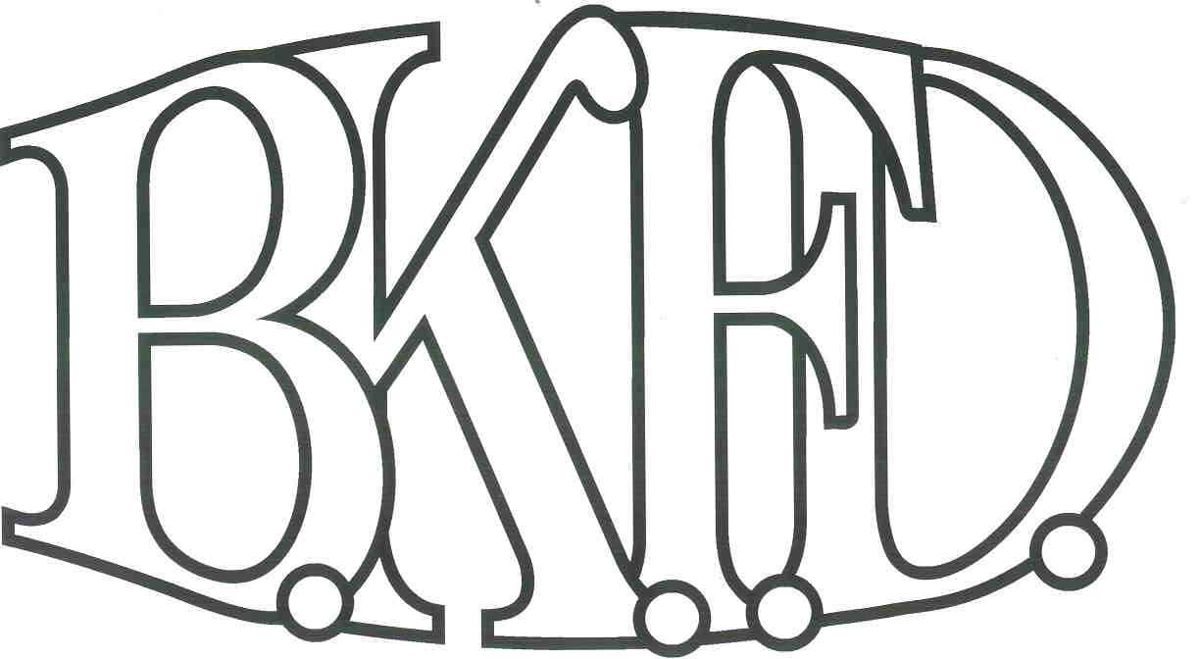
Bristol Kendall Fire Department

103 East Beaver Street

Yorkville, IL 60560

Phone: 630-553-6186

Fax: 630-553-1482

Foreign Fire Insurance Board 07/06/2023 Minutes

The monthly business meeting for the Bristol-Kendall Fire Department Foreign Fire Insurance Board was called to order at 1600 hrs. on 07/06/2023. Roll call was taken showing LT Johnson, Chief Bateman, FF/PM Beck, FF/PM Krouse Present. FF/PM Horner excused.

The minutes were read and a motion was made by Chief Bateman to approve the minutes and a second was made by FF/PM Beck. The minutes for 06/01/2023 were approved.

The treasurer’s report was read and a motion was made by FF/PM Beck to approve the treasurer’s report and a second was made by FF/PM Krouse. The Month’s beginning balance was $167,451.75 and the ending balance is $167,398.95. The treasurer’s report for 07/06/2023was approved.

The following bills were presented for payment: None

Old Business:

None

New Business:

The board acknowledged the Higher Education Intent forms that were submitted by eligible members.

None.

All Intent forms were approved.

The board discussed the annual station fund disbursement. (After discussion, a motion was made to approve the disbursement by FF/PM Beck, and a second was made by FF/PM Krouse.)

The board discussed FF/EMT Debolt class reimbursement. (After discussion, a motion was made to table the proposal for more documentation by FF/PM Beck, and a second was made by FF/PM Krouse.)

The board discussed a proposal submitted by FF/PM Jordan. The proposal was submitted to expand and change the amenities of the back patio at station 3 total cost not to exceed $1100 out of the station 3 allotment. (After discussion, a motion was made to approve the proposal by FF/PM Beck, and a second was made by FF/PM Krouse.)

Roll Call Vote:

Chief Bateman - (Yes)

Brandon Johnson - (Yes)

Nathan Beck - (Yes)

Ryan Krouse - (Yes)

Michael Horner- (Excused)

Proposal (Approved) for funding.

The board discussed a proposal submitted by FF/PM Valaski. The proposal was submitted to Replace kitchen equipment at station 1 total cost not to exceed $950 out of the station 1 allotment. (After discussion, a motion was made to approve the proposal by FF/PM Beck, and a second was made by FF/PM Krouse.)

Roll Call Vote:

Chief Bateman - (Yes)

Brandon Johnson - (Yes)

Nathan Beck - (Yes)

Ryan Krouse - (Yes)

Michael Horner- (Excused)

Proposal (Approved) for funding.

Next meeting 08/03/2023 Station 1 1600hrs

A motion to adjourn the meeting was made by FF/PM Beck with a second made by FF/PM Krouse

Meeting adjourned at 1617.

