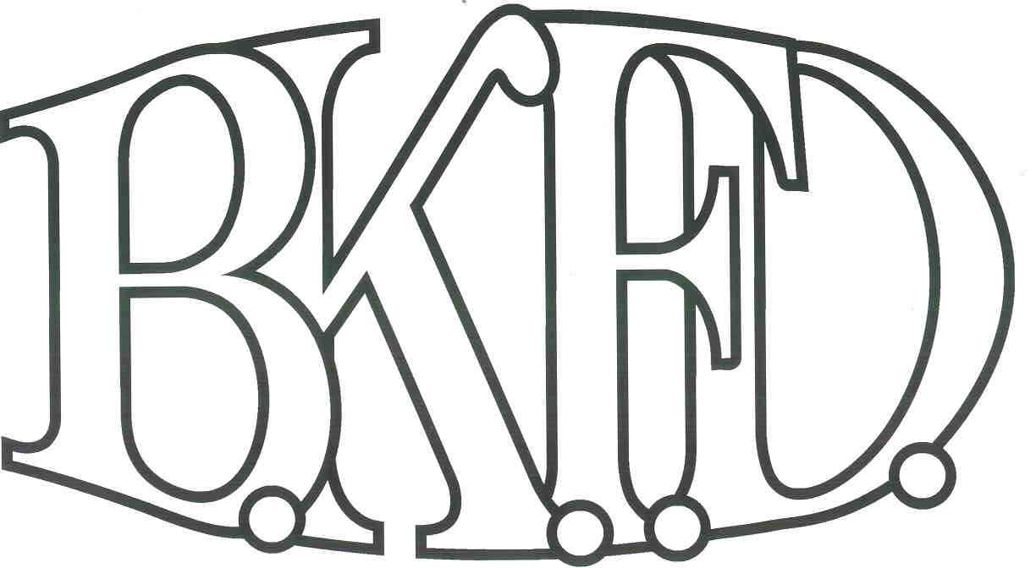
Bristol Kendall Fire Department

103 East Beaver Street

Yorkville, IL 60560

Phone: 630-553-6186

Fax: 630-553-1482

Foreign Fire Insurance Board 12/07/2023 Minutes

The monthly business meeting for the Bristol-Kendall Fire Department Foreign Fire Insurance Board was called to order at 1602 hrs. on 12/07/2023. Roll call was taken showing Chief Messersmith, Lt. Johnson, FF/PM Krouse, FF/PM Beck, FF/PM Horner and AC McCarty present.

The minutes were read and a motion was made by FF/PM Horner to approve the minutes and a second was made by FF/PM Beck. The minutes for 10/15/2023 were approved.

The treasurer’s report was tabled due to account changes being made to separate FFIB from Bristol Kendall Fire Protection District accounts.

Old Business:

Chief Messersmith was appointed Treasurer of FFIB and James Bateman was removed from position. Motion was made by FF/PM Beck and seconded by FF/PM Krouse. Motion carried with unanimous vote.
- A motion to create a local checking account and money market account. Motion was made by FF/PM Beck and seconded by FF/PM Krouse. Motion carried with unanimous vote.

Discussion on shared audit cost was tabled until further information can be provided.

Discussion on Bylaw changes was tabled until further information can be provided.

New Business:

The board discussed a proposal submitted by FF/PM Jordan. The proposal was submitted. Total cost not to exceed $1,400 out of the Station 3 fund. After discussion, a motion was made to approve the proposal by FF/PM Beck, and a second was made by FF/PM Krouse.

Roll Call Vote:

Chief Messersmith - YES

Brandon Johnson - YES

Nathan Beck - YES

Ryan Krouse - YES

Michael Horner - YES

Proposal approved for funding.

The board discussed a proposal submitted by FF/PM Enlow. The proposal was submitted. Total cost not to exceed $5,000 out of the General fund. After discussion, a motion was made to Deny the proposal by FF/PM Beck, and a second was made by FF/PM Krouse.

Roll Call Vote:

Chief Messersmith - YES

Brandon Johnson - YES

Nathan Beck - YES

Ryan Krouse - YES

Michael Horner - YES

Proposal denied for funding. Approval was denied to find a more fiscally responsible water bottle.

- The board discussed a proposal submitted by FF/PM Gruca. The proposal was submitted. Total cost not to exceed $200 out of the Station 2 fund. After discussion, a motion was made to approve the proposal by FF/PM Beck, and a second was made by FF/PM Krouse.

Roll Call Vote:
Chief Messersmith - YES
Brandon Johnson - YES
Nathan Beck - YES
Ryan Krouse - YES
Michael Horner - YES

Proposal approved for funding

- The board discussed a proposal submitted by FF/PM Beck. The proposal was submitted. Total cost not to exceed $45,000 out of the General fund. After discussion, a motion was made to table the proposal by FF/PM Horner, and a second was made by FF/PM Krouse.

Roll Call Vote:
Chief Messersmith - YES
Brandon Johnson - YES
Nathan Beck - YES
Ryan Krouse - YES
Michael Horner - YES

Proposal was tabled requesting a rewritten proposal.

Next meeting will be held at Station 1 on 1/04/2024 at 1600 hrs.

A motion to adjourn the meeting was made by FF/PM Krouse with a second made by Chief Messersmith.

Meeting adjourned at 1652.

